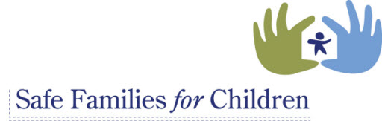

Parent Rights and Information

- It is understood that you are making this hosting arrangement for your child voluntarily (non-coerced). You have a right to withdraw your permission for the hosting arrangement and have your child returned to you whenever you like (SFFC asks 48-hours in order to arrange the transition of your child back to your care).

- You have a right and are encouraged to have regular visits with your child. It is important that these visits are prearranged and coordinated with the SFFC host parent’s schedule.

- You have a right to have regular phone contact with your child. It is important that phone contacts are scheduled ahead of time. SFFC host families have a right to some level of privacy as well.

- You have a right to receive supportive coaching and referrals from SFFC Family Coaches.

- You have a right to have information regarding you and your family to be held in confidence.

- If your child gets sick or requires medical attention, every attempt will be made to contact you. If you are unavailable, the SFFC host family has been given authority by your permission to seek medical treatment.

- SFFC staff are typically available from 8am to 5pm daily. You can reach them at 207-713-0523. Your Family Coach will let you know his/her availability.

- It is expected that you will address the issues that led to this hosting arrangement, while your child is with a SFFC host family. This may include services, treatment, housing assistance and the like that are offered in your community. If it becomes apparent that you are not addressing issues or are involved in services, SFFC hosting arrangements may end. Please remember that we are not able to be simply an answer to lack of childcare.

- If you are unhappy with the help provided to you or your child, please contact you family coach to inform them of that. You can also file a grievance. Your family coach can provide you with that information.

- It is important to note that all Safe Families for Children team members are mandated reporters of suspected child abuse and neglect.

